 | Wordle
Performance Element | Wow!  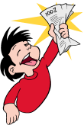5 | Getting there  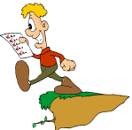4 | Work in progress  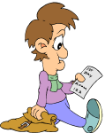 3
Name | Largest word in wordle | Contains name in wordle | No Name
Inherited Traits | Contains at least five traits | Contains 3-4 traits | Contains less than 3 traits
Learned Behaviors | Contains at least five behaviors | Contains 3-4 behaviors | Contains less than 3 behaviors
Appearance | The arrangement of text is visually pleasing | The arrangement of text is visually confusing | There is no arrangement of text

