 | Poster
Performance Element | Wow!  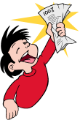5 | Getting there  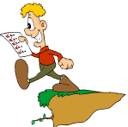4 | Work in progress  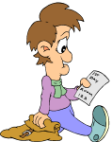 3
Title | Large, legible, and summarizes the theme | Somewhat hard to read and a little hard to connect to the theme | Illegible
Pictures | Contains at least four pictures | Pictures are present but not all are relevant to the theme | No pictures
Captions | Captions are neat, and identify objects | Captions are present but messy | No captions
Text | Text is easy to read and properly spelled | Text is either hard to read or misspelled | There is no text
Appearance | The arrangement of text, title, and pictures is visually pleasing | The arrangement of text, title, and pictures is visually confusing | There is no arrangement of text, title, and pictures.

